Medical Device type/ Usage | Trust standard Model or Range | Ordering information
Critical Care / High Dependency patient monitoring | Philips MP series | Contact MEM to discuss model and requirements | 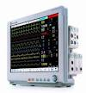
Operating theatre Anaesthetic workstations | GE Healthcare Aespire view or Avance | Contact MEM to discuss model and requirements | 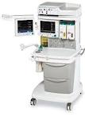
Operating theatre Patient monitoring | GE Healthcare FM, AM or B850/650 | Contact MEM to discuss model and requirements | 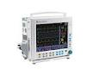
Defibrillator (acute) | Philips XL | M4735A | 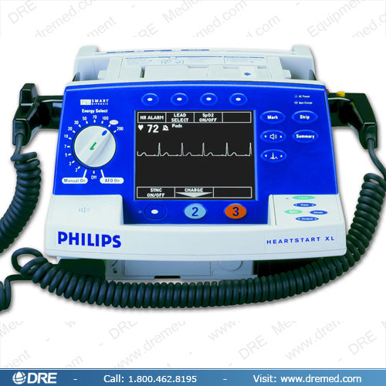
Defibrillator (Low risk and public areas) | Philips FR2 | M3860A | 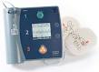
ECG Recorder | MAC 1200 | MAC 1200 | 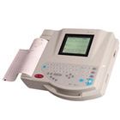
General Obs monitor  (BP/SpO2) | GE Healthcare CARESCAPE V100  (Inc Roll stand) | Carescape V100 | 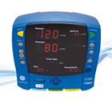
General Obs monitor  (BP/SpO2) | Welch Allyn SPOT Monitor (inc Suretemp thermometry & roll stand) | 42NTB-E4 | 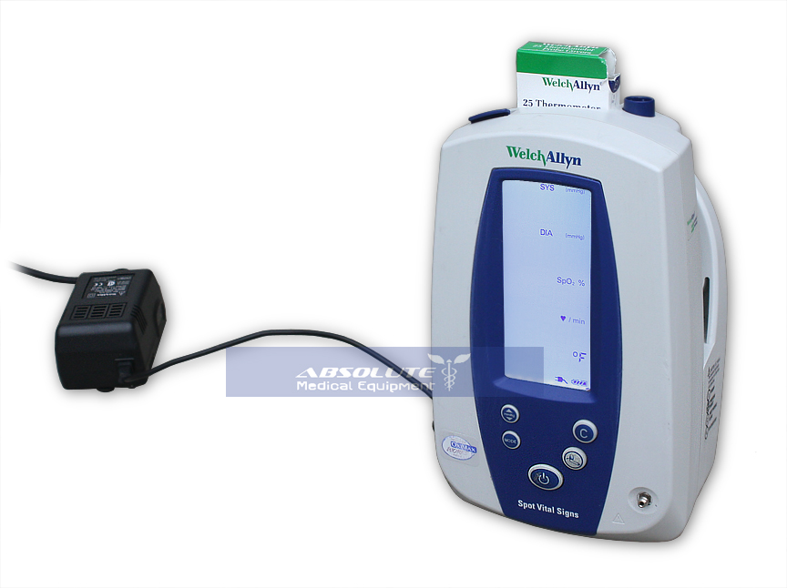
SpO2 monitor | Nellcor N-560 | Contact MEM | 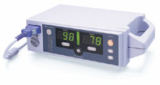
Temperature Monitor (digital) | Welch Allyn Suretemp Thermometry | Contact MEM | 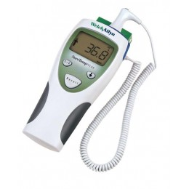
Portable suction | Oxilitre Suction (Optional mounting plate) | Suction unit - PSP002  Mounting Plate – PSP701C | 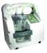
Portable Oxygen regulator | Therapy Equipment  Dial reg / Medi reg | Contact MEM | 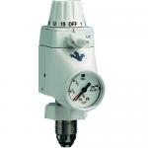
Pipeline Suction | Therapy Equipment Diamond range  High / Low / Thoracic | High – 7701  Low – 7720  Thoracic - 7740 | 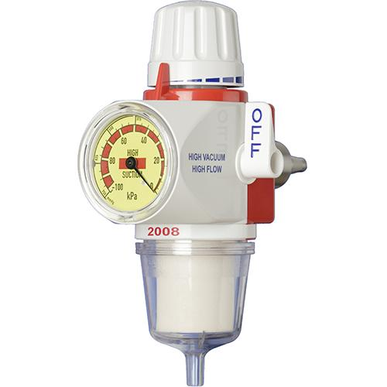
Pipeline Oxygen flowmeter | BOC | Single –  829-0351  Twin –  829-0352 | 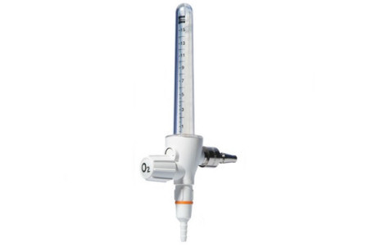
Patient scales  Standing | SECA 761 | SECA 761 | 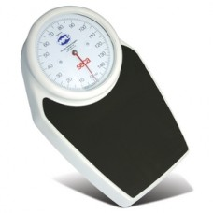
Patient scales  Chair Scales | SECA 959 | SECA 959 | 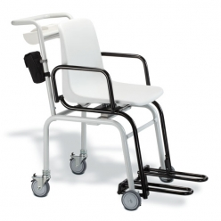
Aneroid manual sphygmomanometer | Welch Allyn 767  (inc Roll stand) | 7670-10 | 